Studio 6

Name and Student Id: Xin Xu 30421225

Self-Evaluation:

|  |  |  |  |  |  |
| --- | --- | --- | --- | --- | --- |
| Need Help | Work in Progress | Pass | Credit | Distinction | ***High Distinction*** |

Tutor Evaluation:

|  |  |  |  |  |  |
| --- | --- | --- | --- | --- | --- |
| Incomplete | Needs improvement | Pass | Credit | Distinction | High Distinction |

Task 6.1:

{Answers}

I have done this

{Screenshots}

A screenshot of showing week 6 application running with validation on “Create” page

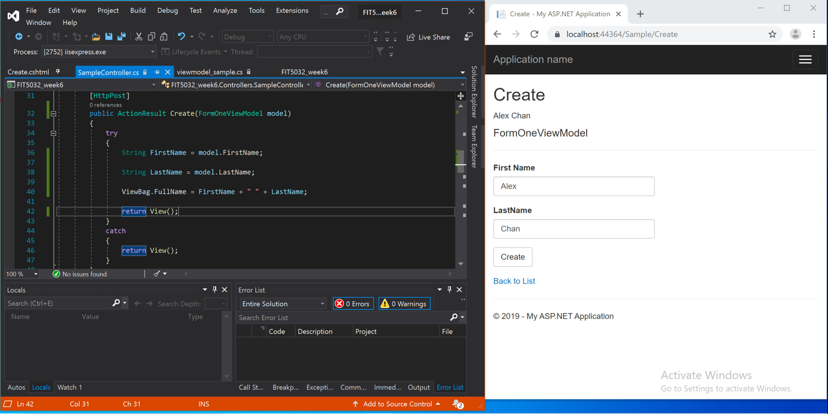

A screenshot of code for FormOneViewModel class and validation

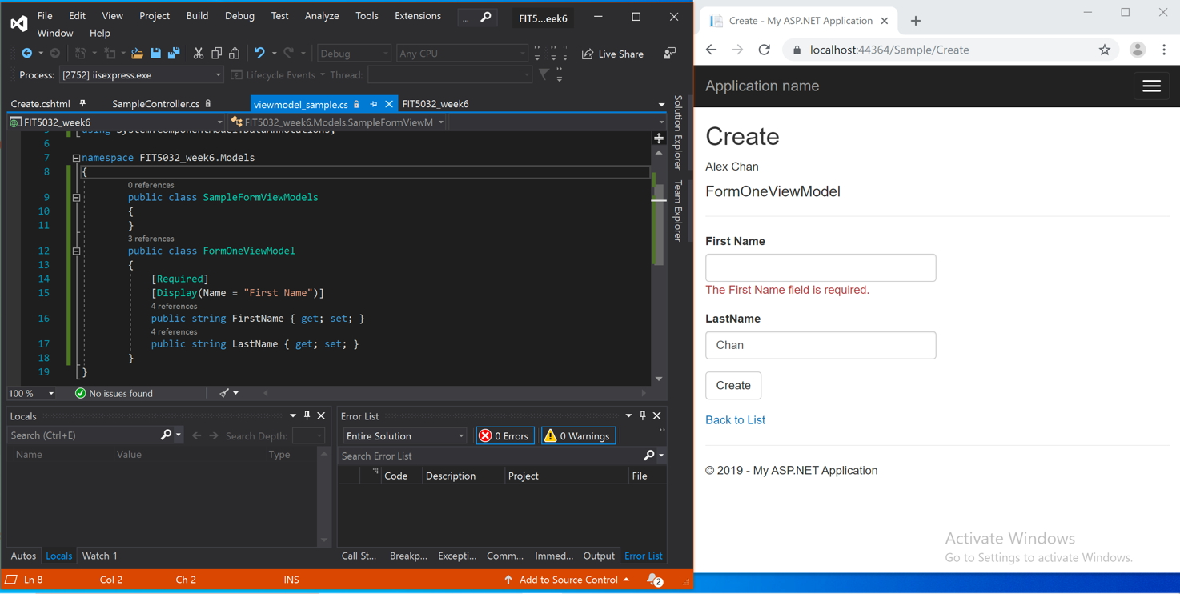

{Link to code repository}

{References}

{URLs}

https://drive.google.com/drive/u/1/folders/1EJm0eM0xhxAZXouHovffv0YsfZgxz1be

Task 6.2:

{Answers}

What it is:

The jQuery unobtrusive validation uses jQuery validate plugin and the unobtrusive library. It allows us to implement simple client-side validation without writing a ton of validation code. The following picture is the simple example.

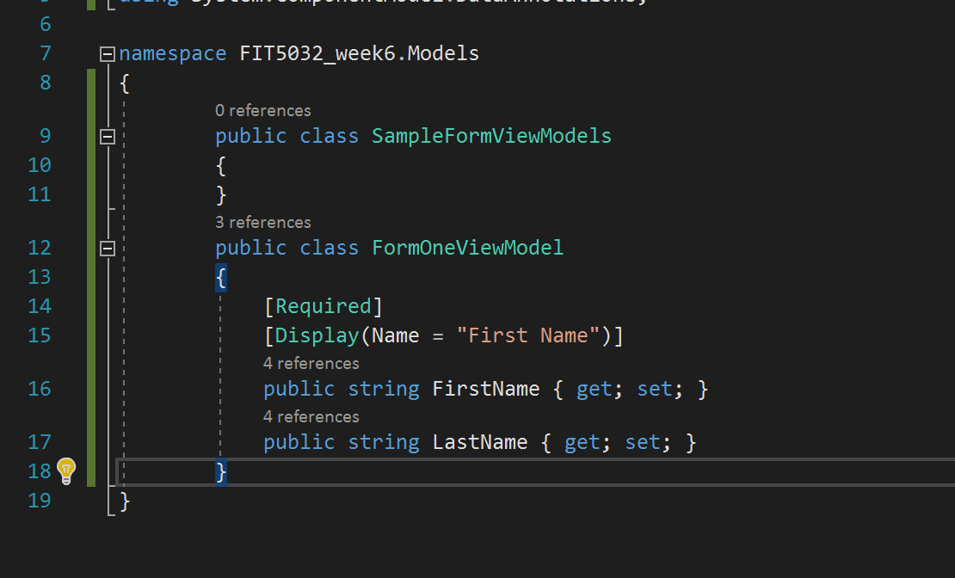

How it works:

It uses HTML5-compatible "data-" attributes to store all of the information it needs to perform validation so that we don’t need other code for validation.

For Model, we just use some simple code such as ‘Required’ and ‘Display’ to meet the needs of validation. Through the code in Model, the error message will show in the view page.

{Screenshots}

{Link to code repository}

{References}

https://exceptionnotfound.net/asp-net-mvc-demystified-unobtrusive-validation/

{URLs}